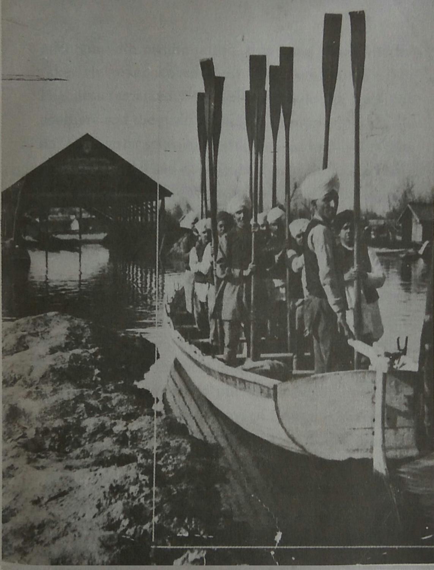

CMS School Boaters saluting his highness Maharaja Pratap Singh in Dal Lake

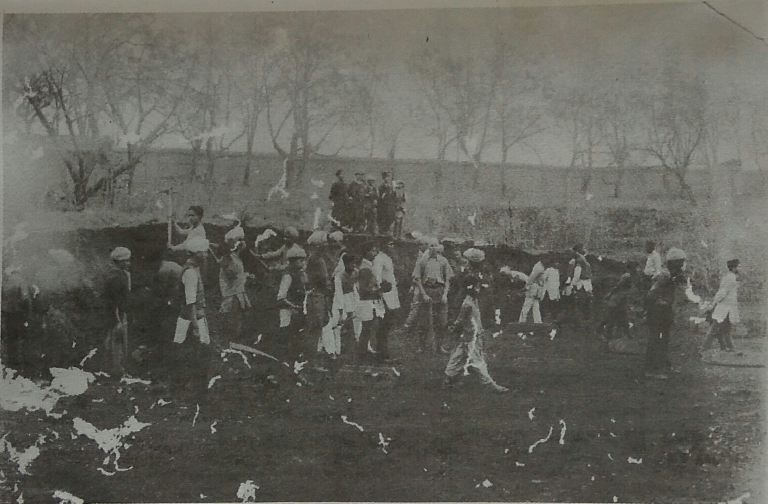

Students of CMS School levelling the ground for the construction of the Mission Hospital at Rainawari in Srinagar. Also seen is Vice Principal Jacob   
(hands on mattock)

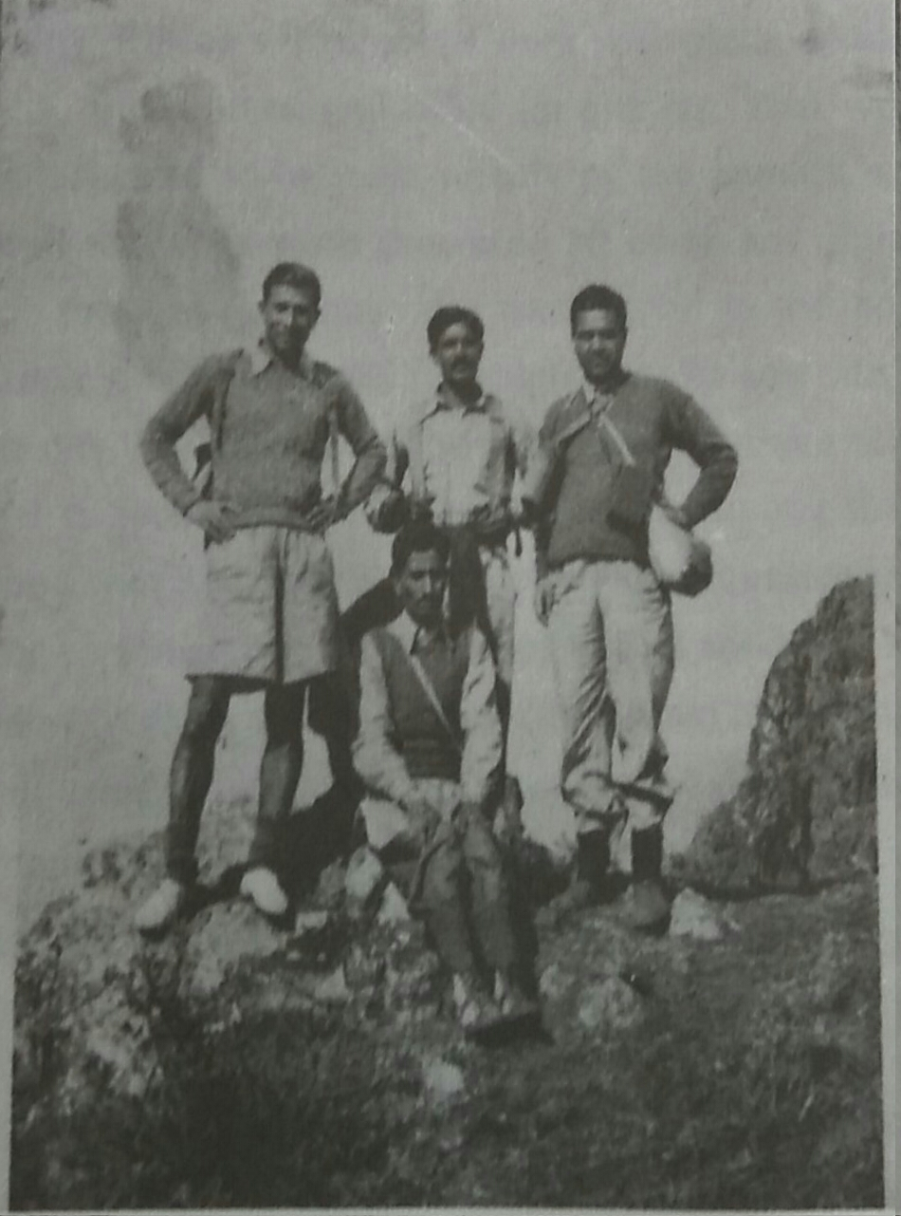

On top of Mahadev: Vice Principal Salam-u-Din Qadri (Sitting) and teachers K N Dhar (left), Edgar Wilson and B B Sapru

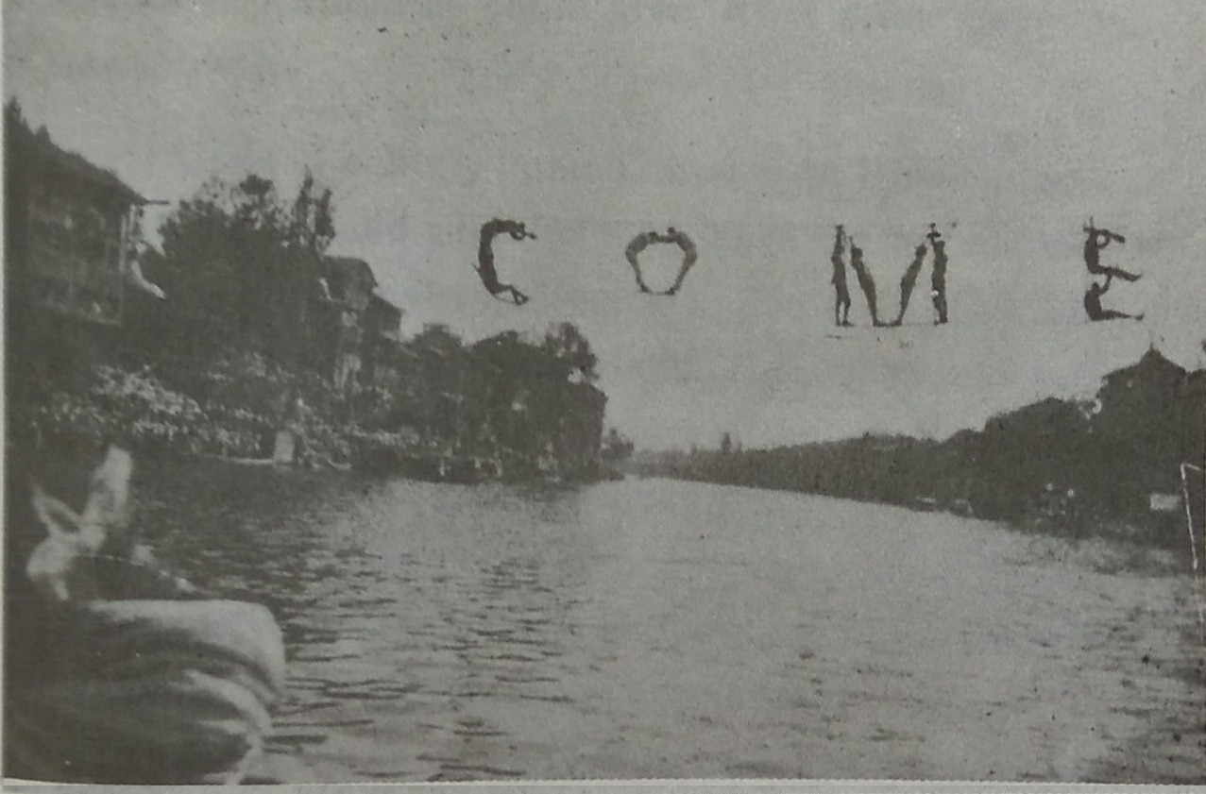

The LIVING WELCOME to Viceroy of India Lord Reading on his Visit to the CMS High School, Fateh Kadal Srinagar